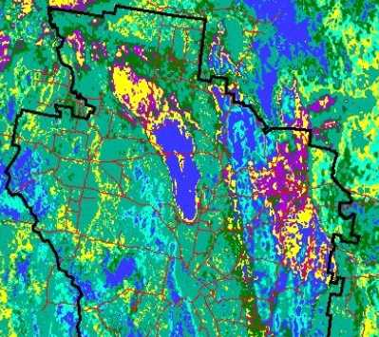
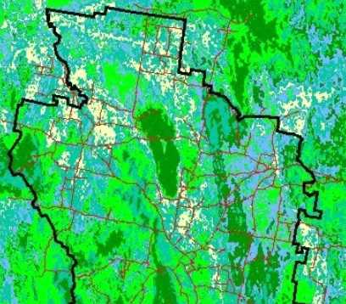
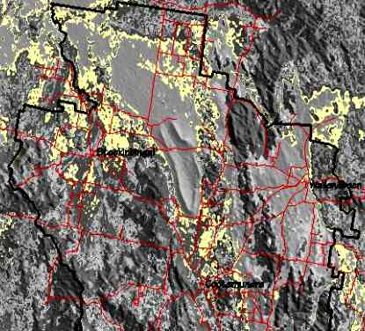
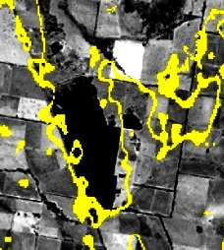
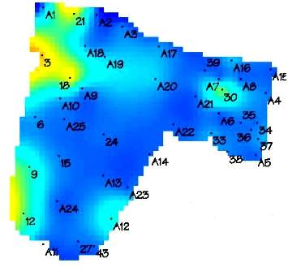
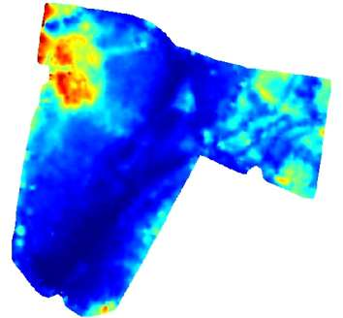
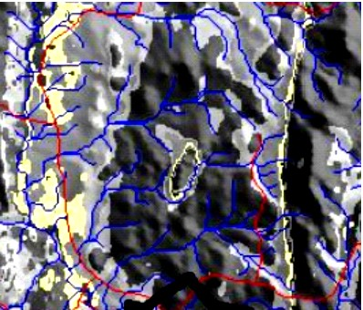
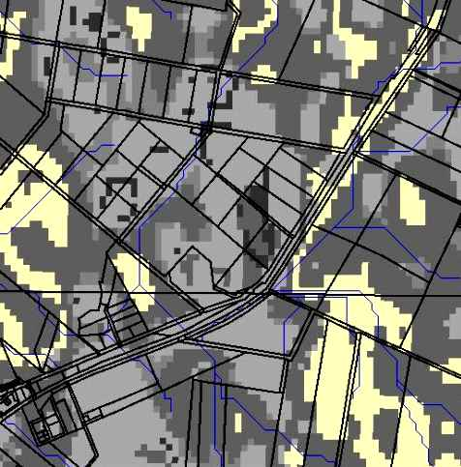
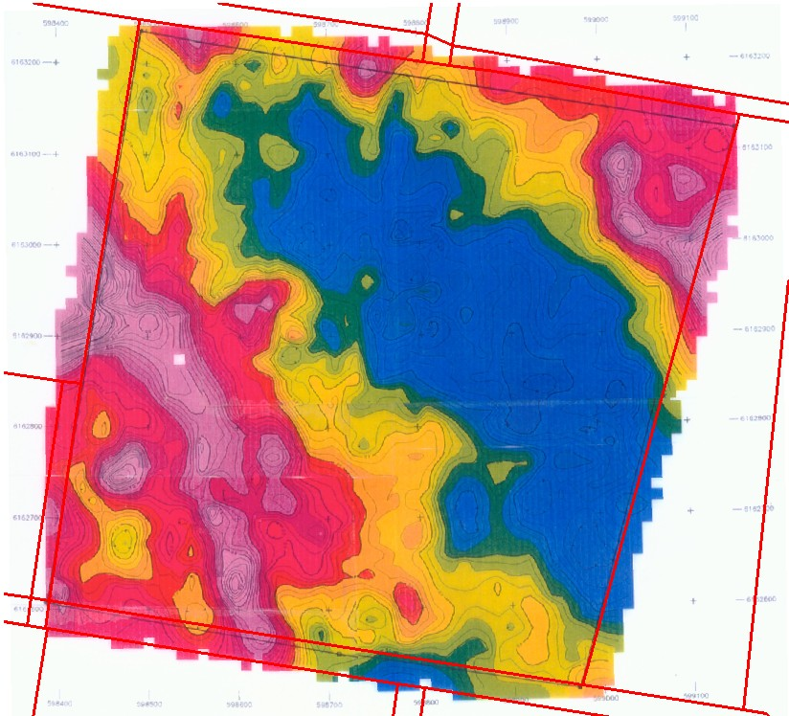
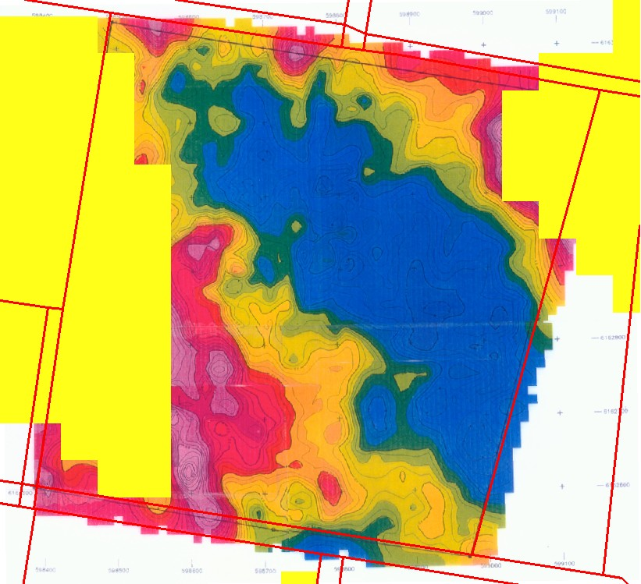
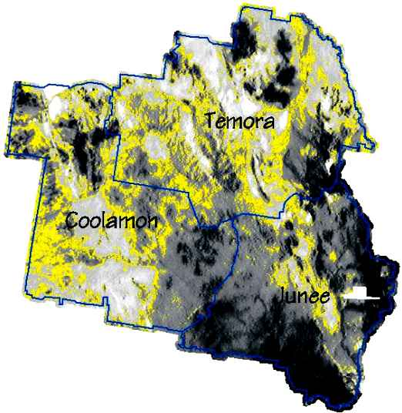
SalinityMap Products
Environmental Research & Information Consortium Pty Ltd

(ABN) ACN (81) 055 194 771

Ph 02 4842 8182
Ph 02 6161 3716

Fax 02 4842 8183

info@eric.com.au
www.eric.com.au
3 expressions
Impact on road
EM31
Salinity information from airborne radiometrics
Regional EC
Dispersibility
High salinity
Extrapolated salinity class
Paddock detail
Measured EC
(at 40 cm)
EM 31
Forms of salinity expression
Natural topographic drainage
Changes to drainage by constructions
Drainage along fault lines
Seepage at break of slope

Surface fit to ground observations
EM 31
Salinity class over EM31

